.35 Remington

- Article
Bottom of Form
From Wikipedia, the free encyclopedia
.35 Remington
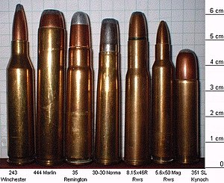
Type | Rifle
Place of origin | United States
Production history
Designer | Remington
Designed | 1906
Manufacturer | Remington
Produced | 1906–present
Specifications
Case type | Rimless, bottleneck
Bullet diameter | .358 in (9.1 mm)
Neck diameter | .384 in (9.8 mm)
Shoulder diameter | .405 in (10.3 mm)
Base diameter | .458 in (11.6 mm)
Rim diameter | .460 in (11.7 mm)
Case length | 1.920 in (48.8 mm)
Overall length | 2.525 in (64.1 mm)
Primer type | Large rifle
Maximum pressure (CIP) | 39,900 psi (275 MPa)
Maximum pressure (SAAMI) | 33,500 psi (231 MPa)
Maximum CUP | 33,500 CUP
Ballistic performance
Bullet mass/type | Velocity | Energy
200 gr (13 g) Lead FN | 2,084 ft/s (635 m/s) | 1,929 ft⋅lbf (2,615 J)
180 gr (12 g) FN | 2,122 ft/s (647 m/s) | 1,800 ft⋅lbf (2,400 J)
200 gr (13 g) RN | 2,071 ft/s (631 m/s) | 1,905 ft⋅lbf (2,583 J)
200 gr (13 g) FTX (Hornady Flex Tip Expanding)^{[2]} | 2,225 ft/s (678 m/s) | 2,198 ft⋅lbf (2,980 J)

Test barrel length: 24
Source(s): Accurate Powder ^{[1]}
The .35 Remington (9.1 x 49 mm) is the only cartridge from Remington's lineup of medium-power rimless cartridges still in commercial production. Introduced in 1906, it was originally chambered for the Remington Model 8 semi-automatic rifle in 1908.^{[3]}
It is also known as 9 x 49 mm Browning, 9 x 48 mm Browning, and 9 mm Don Gonzalo.^{[4][5]}

History
Over the years, the .35 Remington has been chambered in a variety of rifles by most firearms manufacturers, and continues in popularity today in the Marlin Model 336 lever-action and Henry Side Gate Lever Action. It is also a popular cartridge for single-shot hunting pistols like the Thompson/Center Contender and the Remington XP-100. For hunters looking for a medium-power rifle with moderate recoil, for short to medium ranges, the .35 Remington is popular alongside the .30-30 Winchester.^{[6]} It has a small but loyal following in the northeast and areas of the southern United States.^{[6]}
The cartridge uses a medium to heavy bullet and has moderate recoil based on a moderate pressure level of 33,500 CUP as set by SAAMI.^{[1]} The normal factory load consists of a 200 grain round-nosed bullet with a muzzle velocity of 2080 feet per second. This 200 grain bullet is nearly 18% heavier than the .30-30's 170 grain bullet, and has a 16% larger frontal area. This gives it a substantial increase in power over the .30-30, especially when used on larger game species.
Remington helped promote the advantage in power that the .35 Remington had over the .30-30 through a series of advertising campaigns in the early 1900s. One of their advertisements even publicized the ability of the .35 Remington to penetrate a ⁵⁄₁₆-inch (7.9 mm) steel plate, which the .30-30 Winchester could not do.^{[6]}
The .35 Remington is considered a fine round for deer, elk, black bear, and other medium and large game as long as ranges are reasonable.^{[7]} Hornady currently produces a .35 Remington load in their LEVERevolution line that features a rubber-tipped spitzer bullet which is safe to use in lever-action or pump-action firearms with tubular magazines.
- 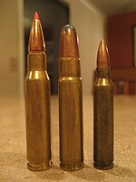
(Left to right) .308 Winchester, .35 Remington Soft Point, and .223 Remington

Dimensions

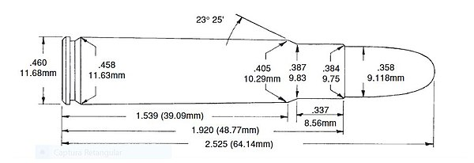

See also
[edit]
- .30-30 Winchester
- .360 Buckhammer
- 9 mm caliber
- List of rifle cartridges
- Table of handgun and rifle cartridges

References

^ Jump up to:ª ^{b} ".35 Remington Accurate Online Reloading Data" (PDF). Archived from the original (PDF) on 2010-06-02. Retrieved 2007-08-13.
  - ^ "35 Rem 200 gr FTX LEVERevolution". Hornady Manufacturing Company. Archived from the original on 2022-03-28. Retrieved 17 November 2021.
  - ^ Fryxell, Glen. "The .35 Remington: America's Other Levergun". Archived from the original on 2021-10-25.
  - ^ https://weaponland.ru/board/patron_35_remington_9x48_browning_9x49_mm/38-1-0-437?utm_source=warfiles.ru
  - ^ https://municion.org/producto/35-remington/
  - ^ Jump up to:ª ^{b} ^{c} McAdams, John (2014-07-28). ".35 Remington: Ultimate Guide To What You Need To Know". The Big Game Hunting Blog. Archived from the original on 2021-11-17. Retrieved 17 November 2021.
  - ^ Hawks, Chuck. "The .35 Remington". Archived from the original on 2021-04-18.

External links
Wikimedia Commons has media related to .35 Remington.
- .35 Remington
- The Enduring .35 Remington
- The .35 Remington: An underrated brush cartridge
- Head to Head: .30-30 Winchester vs. .35 Remington
- Favorite Loads for the 35 Remington - Richard Mann on YouTube

